**Why spark :-**

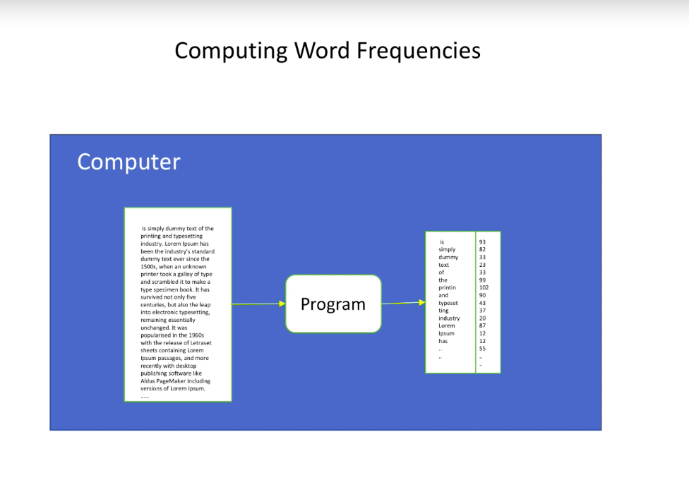

Normally hashmap will do . But for big data it’s a entirely different story.

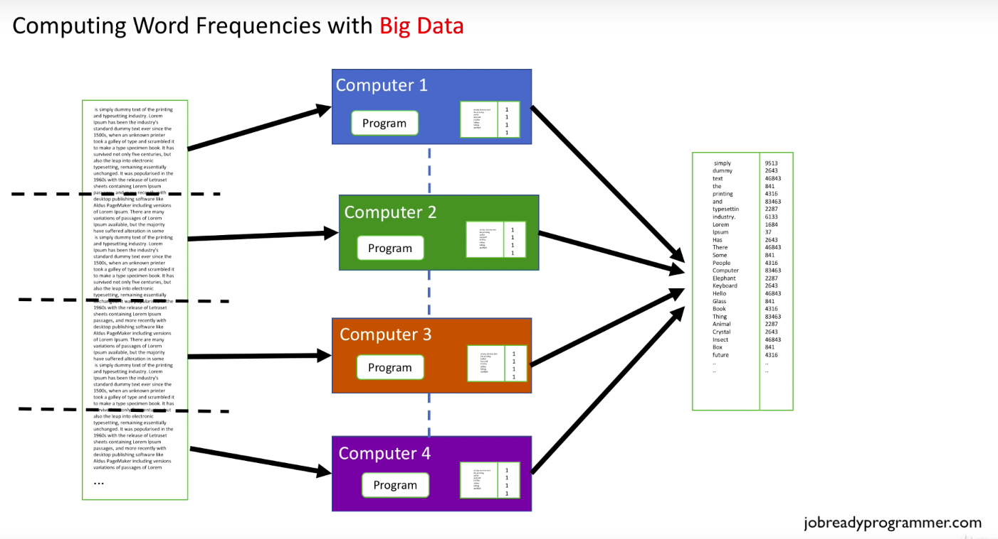

So lets see ,how it will look when we work with big data and instead of single node there is a cluster.

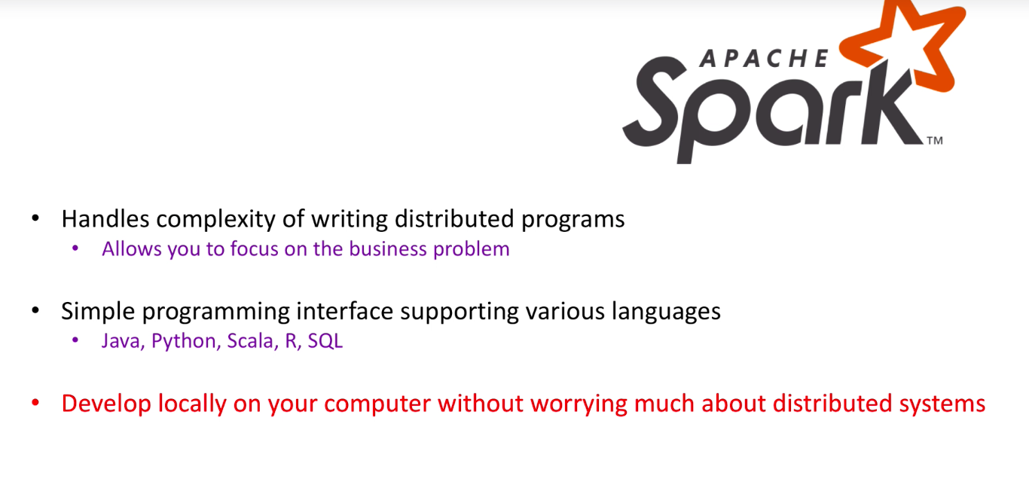

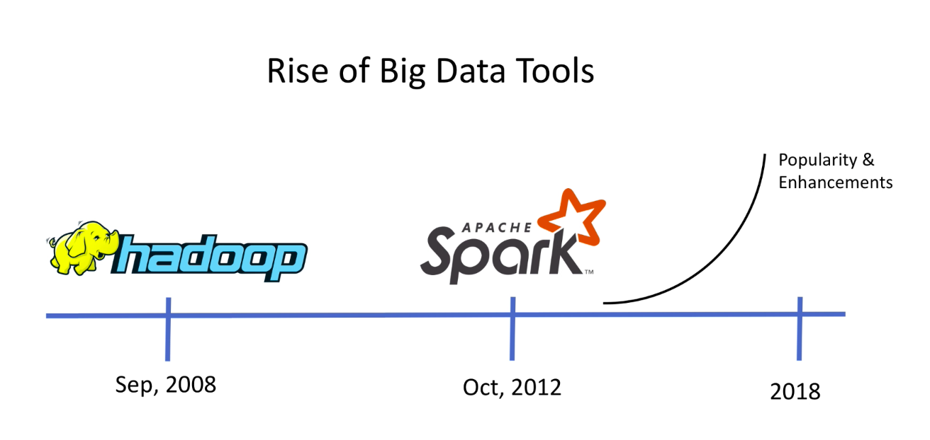

spark is next gen tool for big data analytics . Its 100 times faster than Hadoop . The main reason behind this speed improvement is sparks unique design of keeping large amounts of data in memory whereas Hadoop saves the intermediate steps of data processing on disk. And as we know reading and writing to disks is expensive . But this doesn’t mean that reading and writing does not happen in spark .It happens a lot less than Hadoop and that is why it’s much faster.

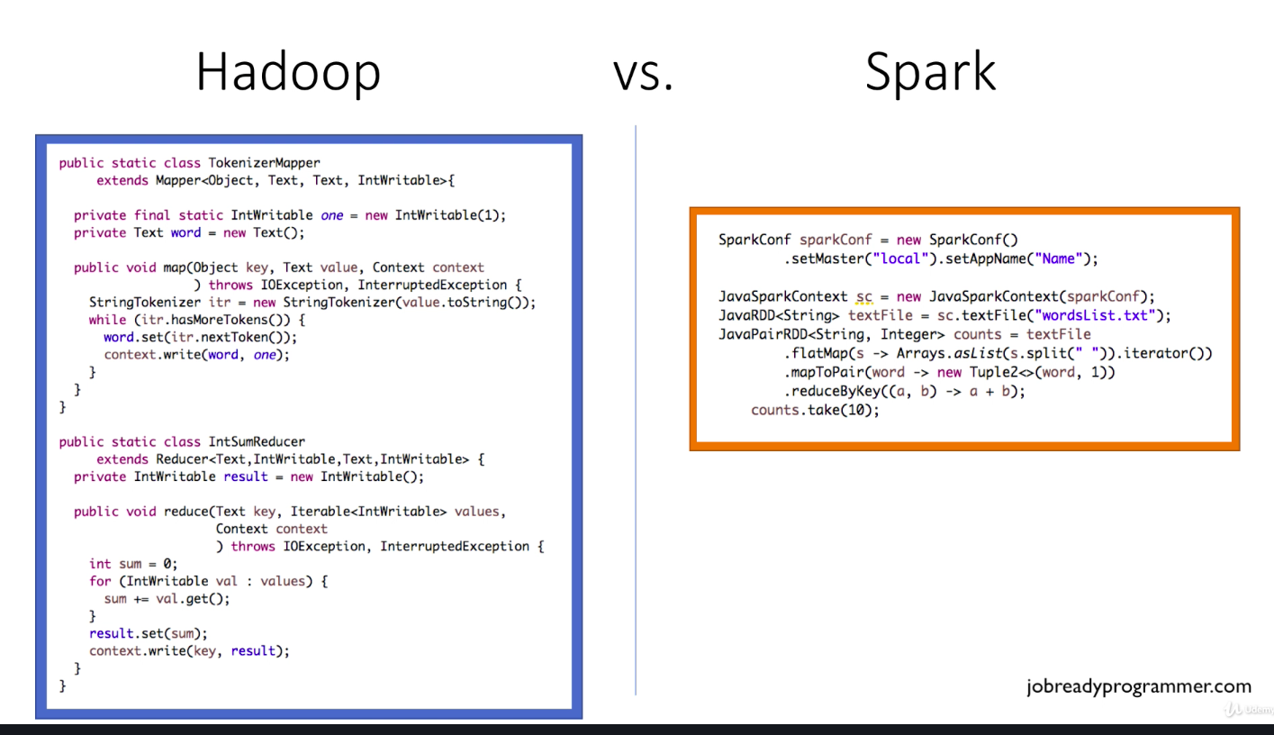

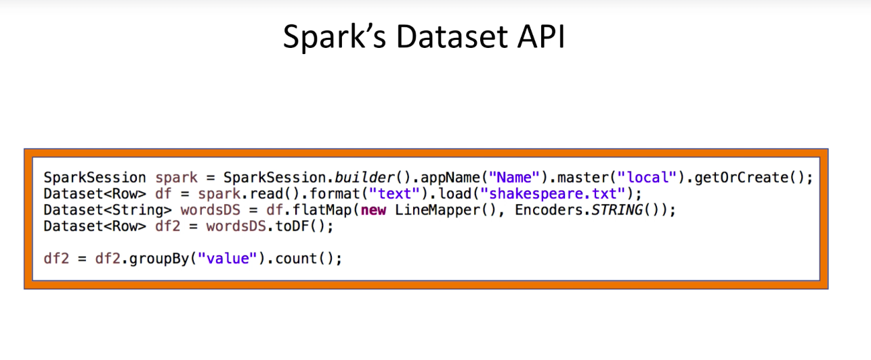

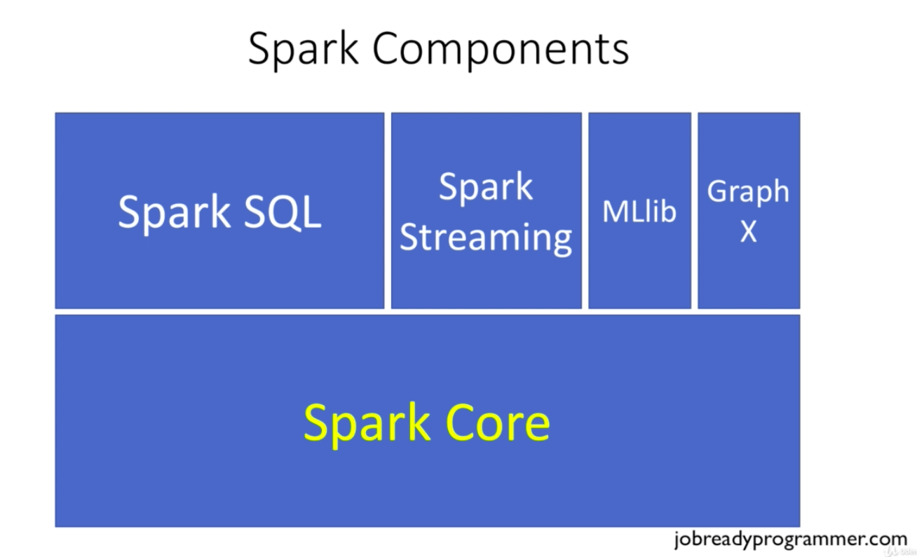

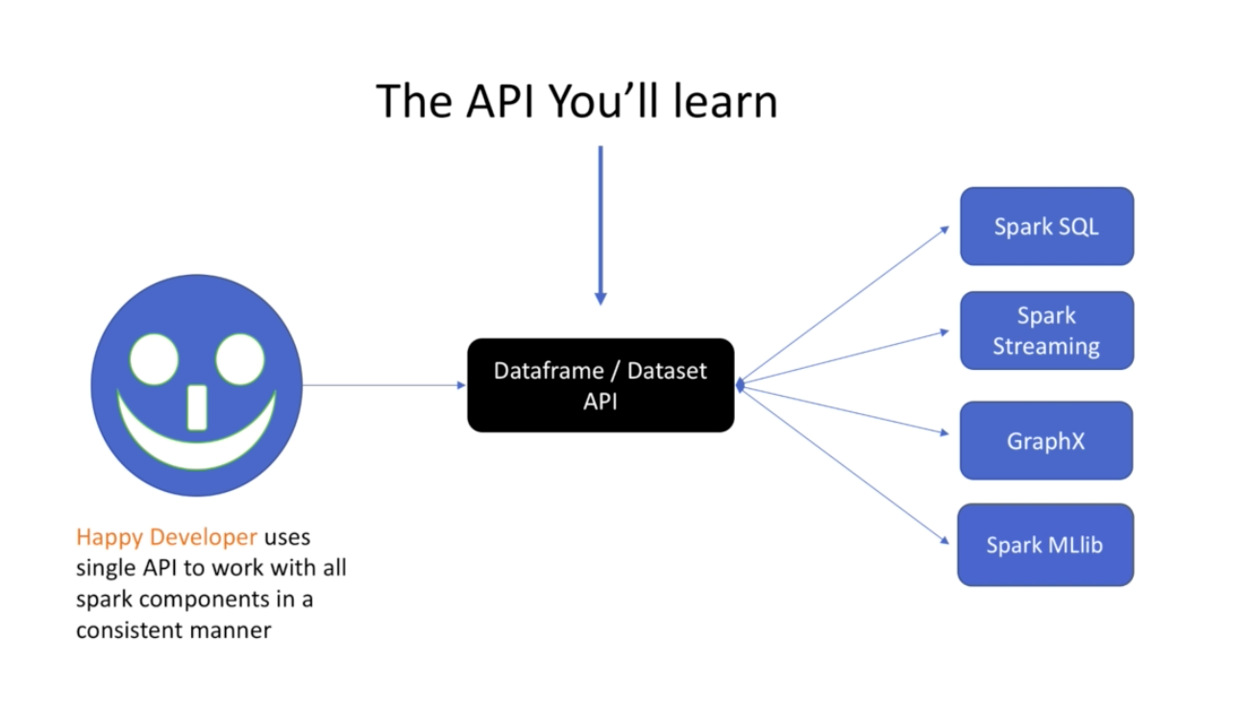

Data sets are immutable structures which means they cannot be changed. They can only be recreated.

Go to project 1 in spark course.

The git hub link is :-

<https://github.com/imtiazahmad007/sparkwithjava>

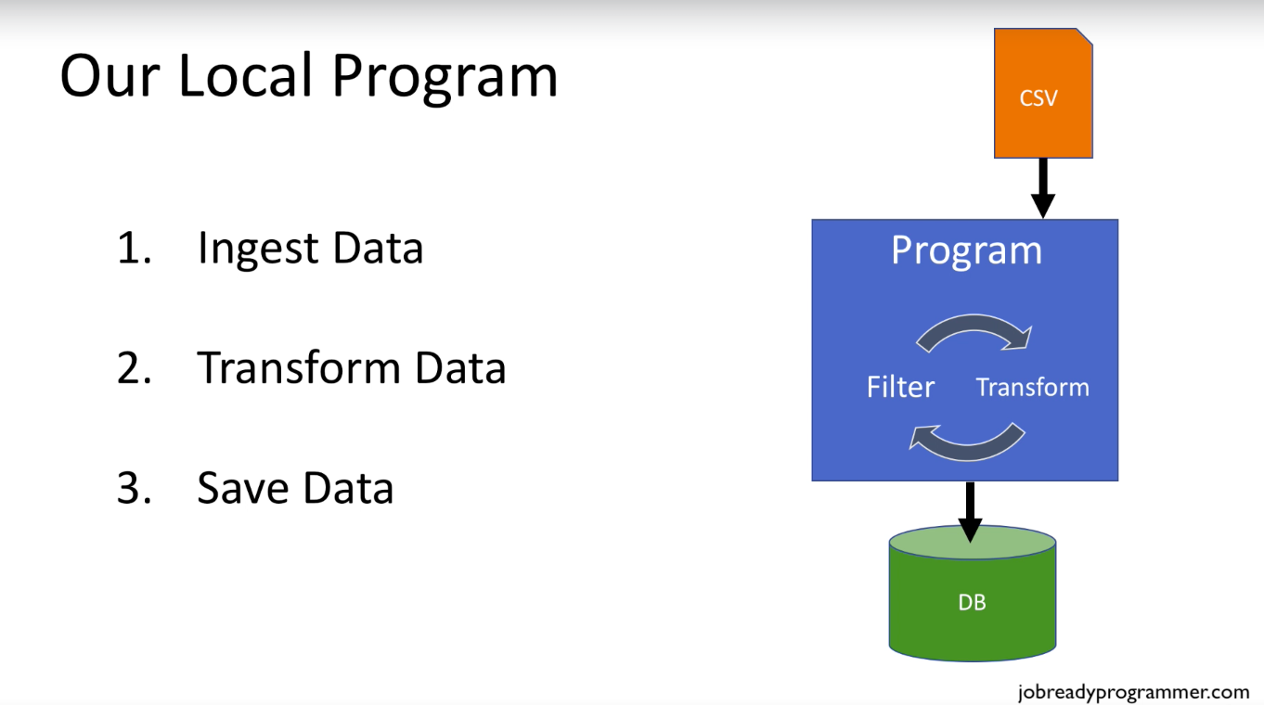

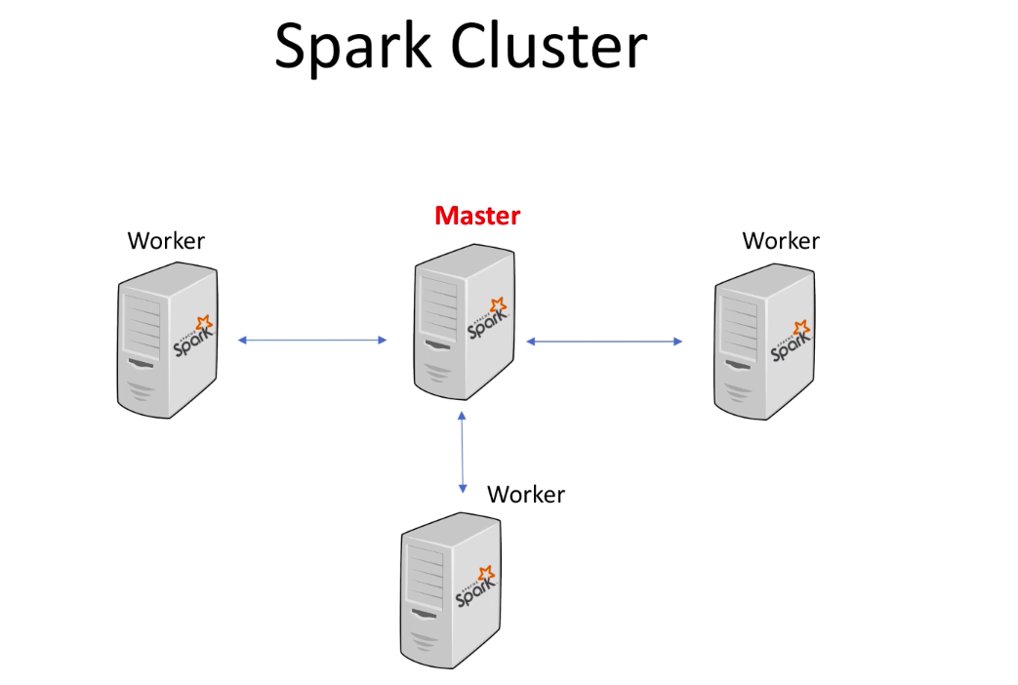

Master node :- primary responsibility is to make sure that workers are up and running.If the worker node crashes , the master can restart it.All the work gets done by workers.Workers are the guys that execute spark code.

Step 1 :- We will submit the code to the master node .Typically , this is done by packaging up our code into jar file and submitting it to the master node.

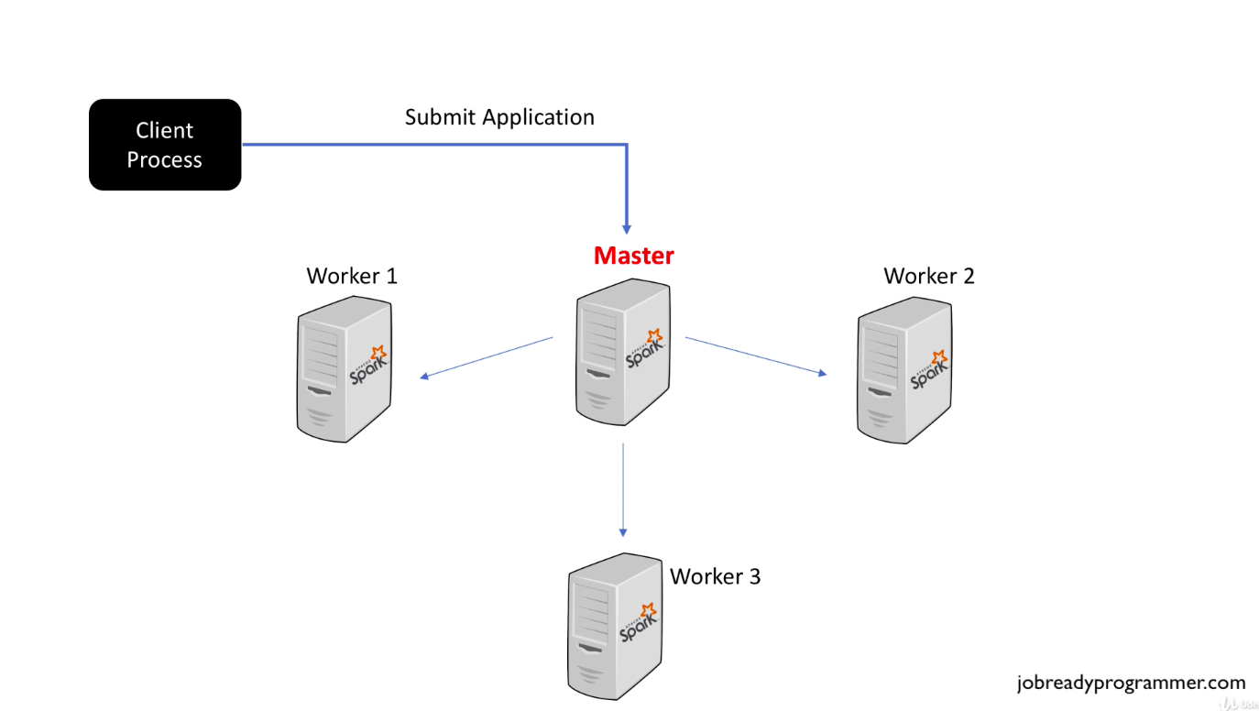

Step 2:- Once the code is submitted , master node then launches processes into worker nodes. The processes running on the worker nodes are the things that actually execute our code.

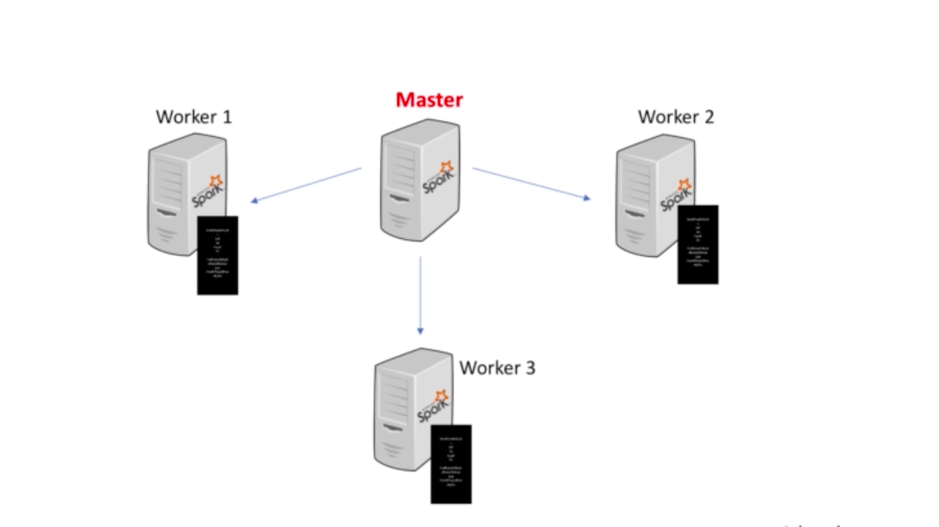

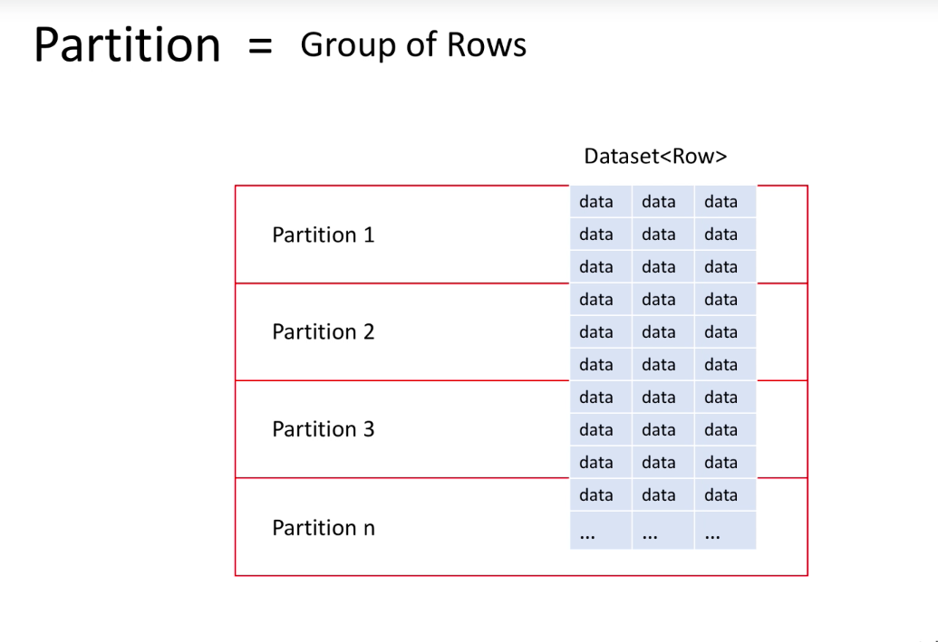

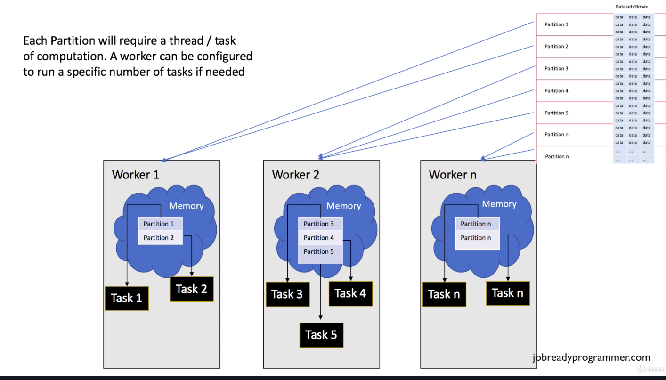

In spark land threads are referred to as tasks. we can configure a worker node to contain many task threads.These tasks represent the code that we wrote in project 1 .These tasks will each be going to read the partition of the file, perform the transformations and filtering that we specified in the code and then finally each task will form the connection with the database and load their respective partitions into the table that we specified in the code.

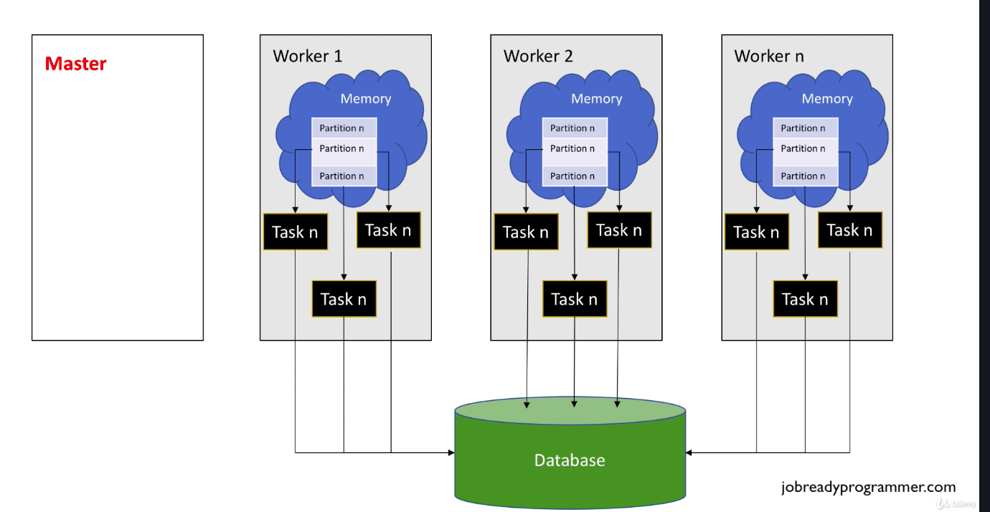

Most databases will have restrictions in the number of connections we are using .so IN REAL world we will be using connections pools for this.

Also in real world , real data sits in a distributed file system or s3 .So the worker node will know how to ingest data from distributed file system as well. So we don’t have to write any extra code for that. Spark takes care of that.

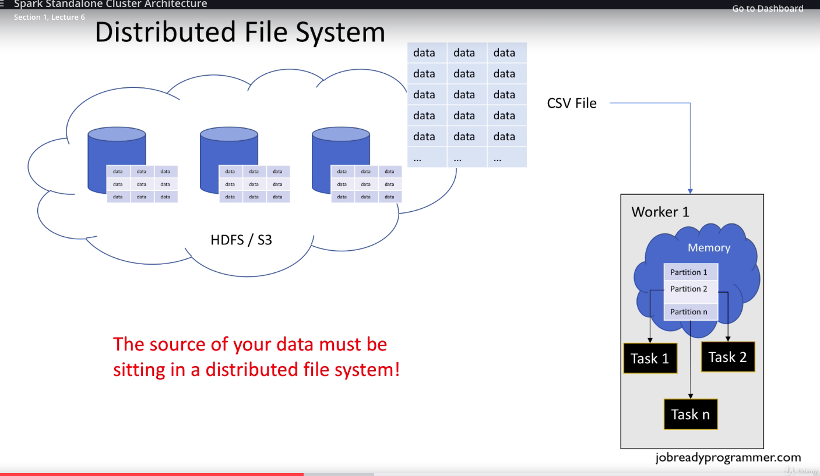

Let’s go back again and see

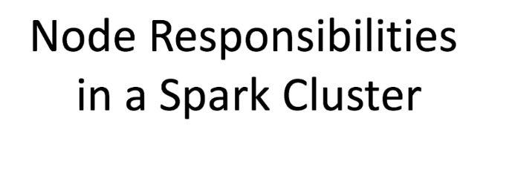

Above, the discussion was quite simplistic view , following we will be going into deeper discussion.

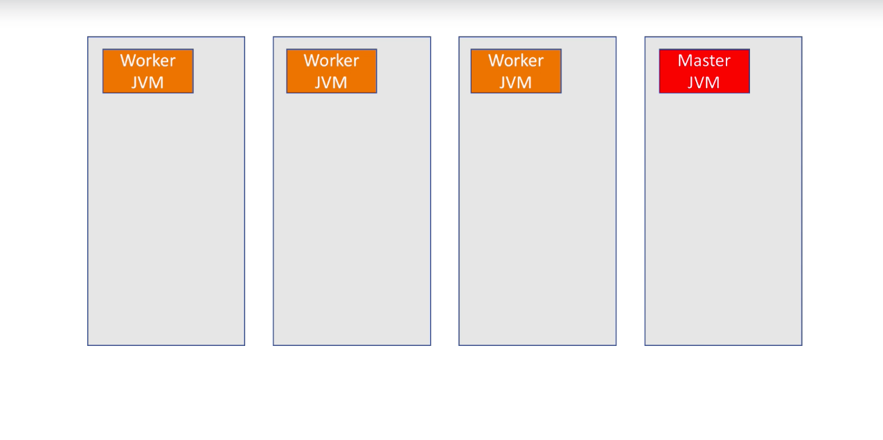

In the beginning , when you set the spark cluster , master node will have master jvm and worker nodes will have worker jvm. You set this up first and that’s the infrastructure and then you submit your application (jar) to the master. What happens next ? Once your application is submitted to the master node . Driver PROCESS Is a very important process(heart of spark job)

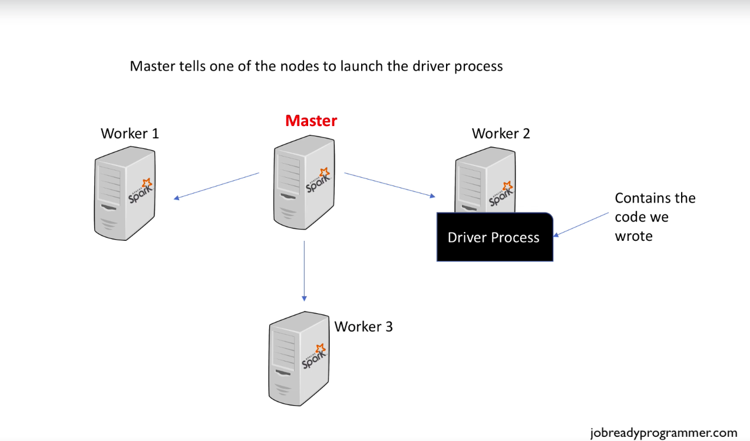

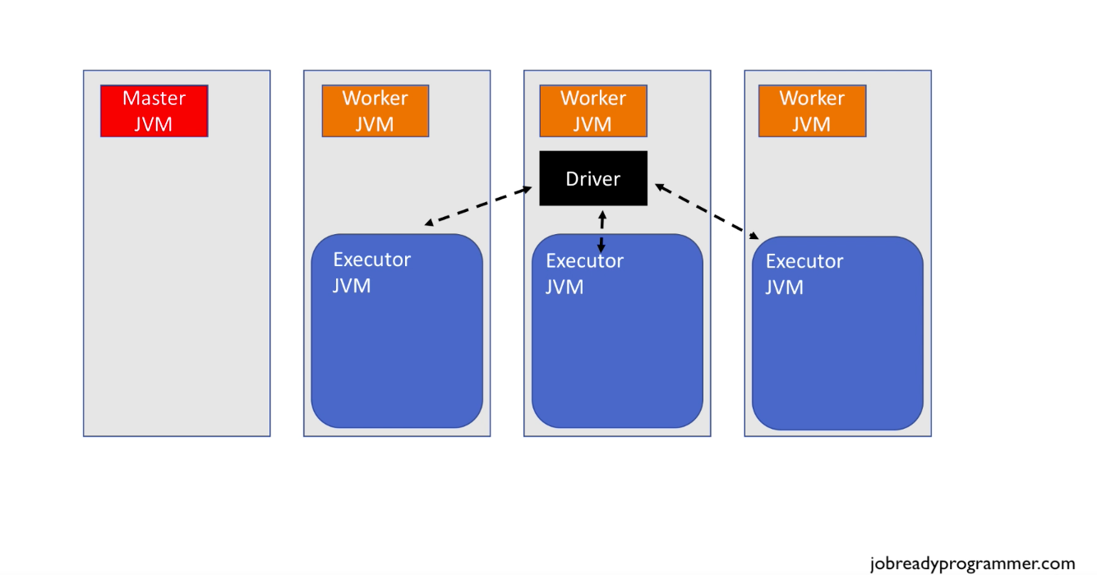

So step1 :- master will spawn driver process in one of the worker nodes (node 2 in this case)

Step2 : driver sitting in node 2 will ask master jvm to spawn a process in each of the worker nodes so that they can begin executing code that the driver contains .So the master node will ask each of the workers to launch jvm in which execution of the code will take place and these jvm processes is called Executor jvm in each node .

Step3 :- Driver will be orchestrating /communicating to every node in the cluster . Driver process will ensure that each node in the cluster is working on the tasks which has been assigned.

DRIVER IS THE ORCHESTRATOR, THE HEART OF SPARK JOB.

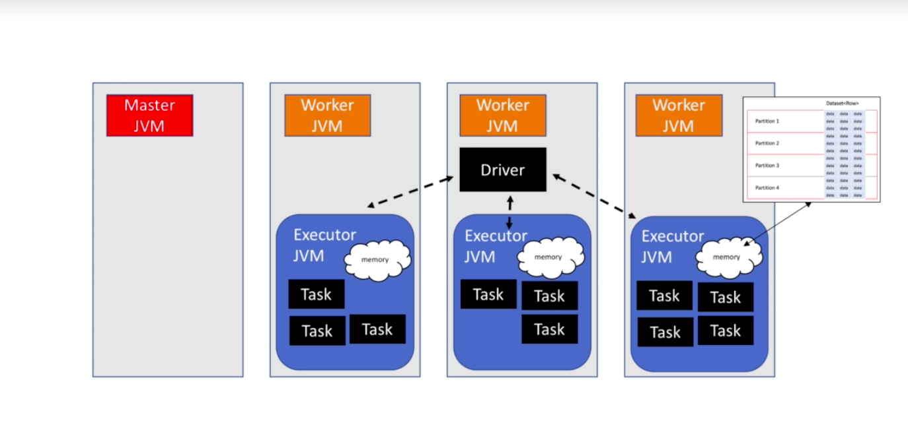

A little bit detail :- The driver node actually tells master node to hand out the instructions to each of the worker nodes. Make sure that you allocate enough memory to these executor programs.

Now some more addition to final concept :-

Master nodes can be highly available, so we can actually tune workers to have this master process running , so if one master goes down we will not have any issue. Similarly, we can launch an executor process in master node as well. The below diagram explains that :-

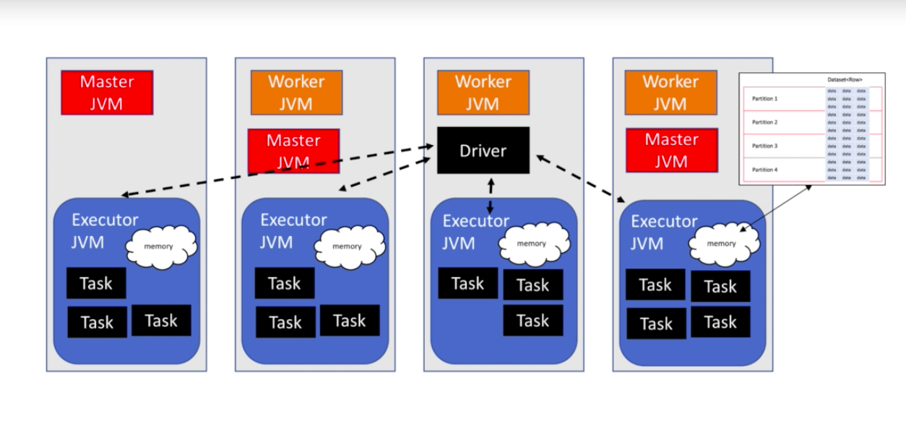

If an executor processor crashes , the worker process is capable of starting it again.

If the worker processor crashes , the master process is capable of starting the worker again.

There is only one driver , so if it goes down , the master will again have to re-initiate It .

Recommendation :- if there are n cores available for a worker , then it advisable to have 2or3 times number of cores- task per worker .So number of cores * 2or 3 task per worker should be configured.

Now lets do project 2 in spark git hub link :-

<https://github.com/imtiazahmad007/sparkwithjava>

**How to reduce logging in the console**

When you're first learning Spark, it's a good idea to keep all of the logging turned on so that you can follow what Spark is doing during every step of running your program. But if you get tired of seeing all of that being printed to the console, you can turn off INFO log entries by following the steps below. Add the following imports to the top of the class that contains your main method.

* import org.apache.log4j.Logger;
* import org.apache.log4j.Level;

After that, inside your main method, add the following 2 lines.

* Logger.getLogger("org").setLevel(Level.ERROR);
* Logger.getLogger("akka").setLevel(Level.ERROR);

This should now only show the error messages, and your console prints and ignore all of those INFO messages.

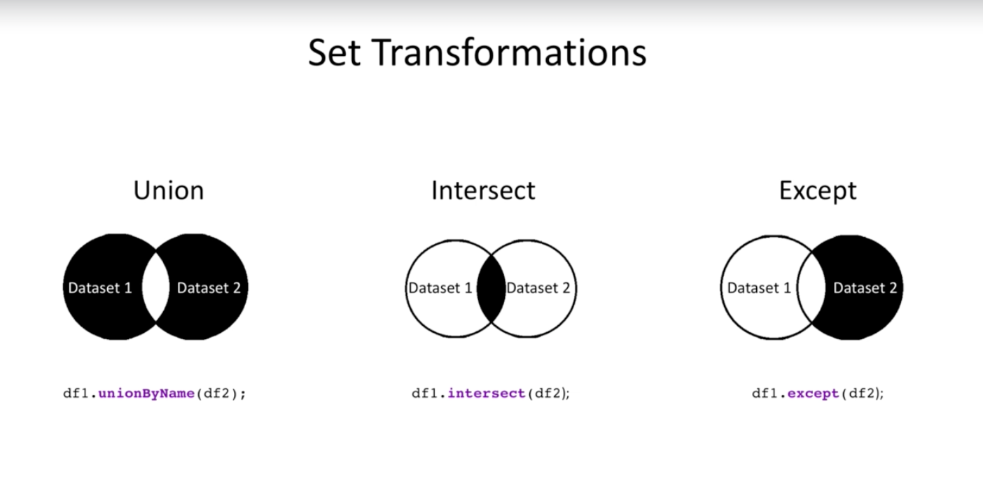

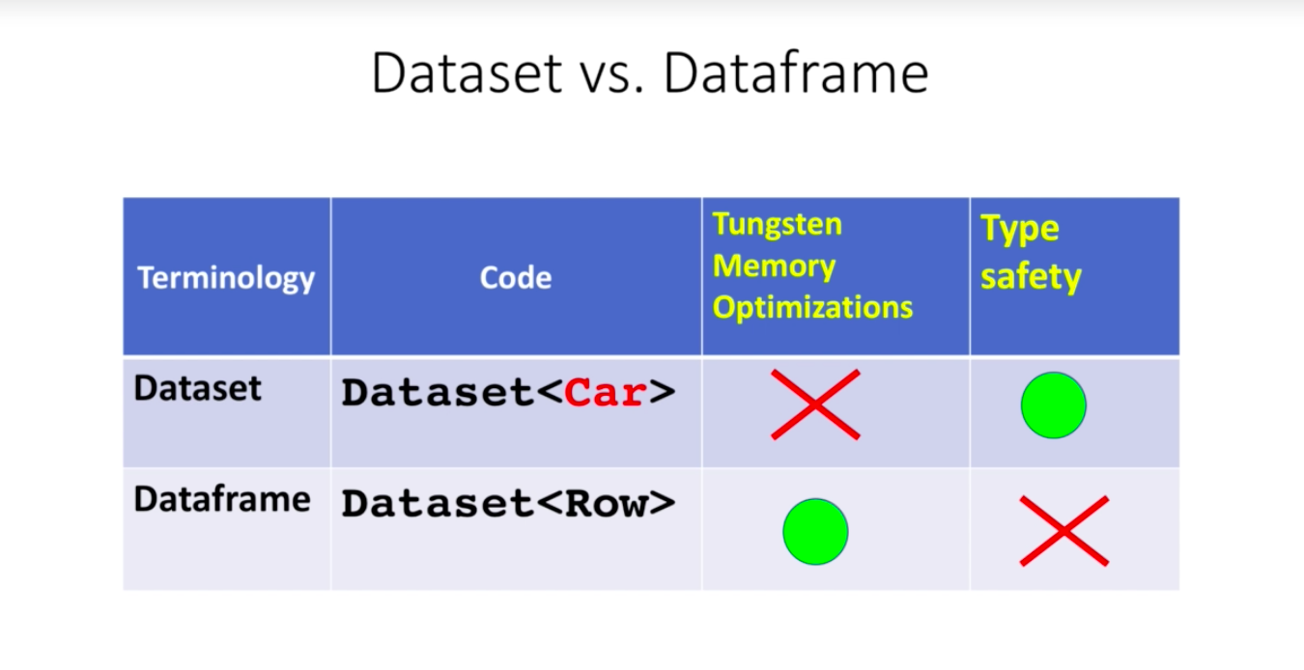

Dataset<String> ds = spark.createDataset(data, Encoders.STRING());

//convert from dataset to dataframe

Dataset<Row> df =ds.toDF();

//convert from dataframe to dataset

Dataset<String> ds1= df.as(Encoders.STRING());

Also if we do any sql functions on datasets like ds1.groupBy etc etc , the return type will be always a dataframe

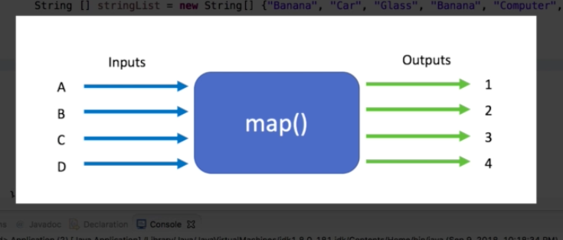

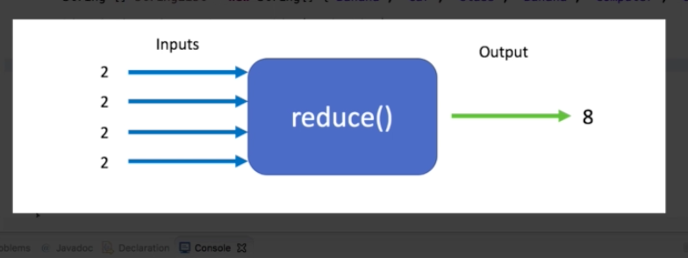

Data frame allows tungsten project optimization for binary processing and memory optimization so to utilize those optimizations its necessary to convert your datasets to data frames like below. So always convert your datasets to data frames before doing any real kind of processing.

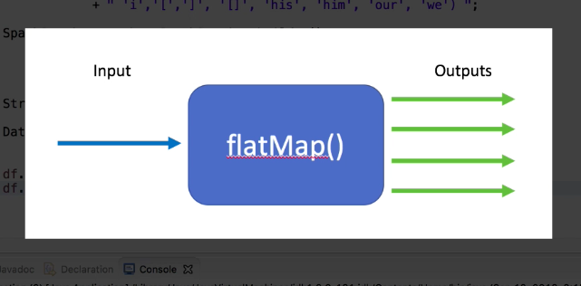

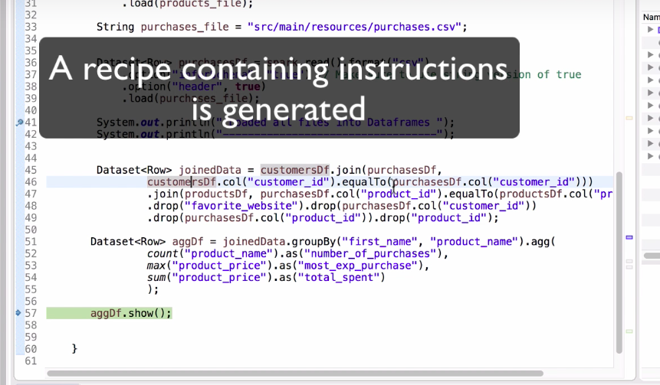

So till the time you run action command (collect,show ..etc ), nothing is happening in spark.

Just like java 8 streams .Intermediate operations and terminal operations.So till the debug point above instructions are added to the recipe sheet called DAG.

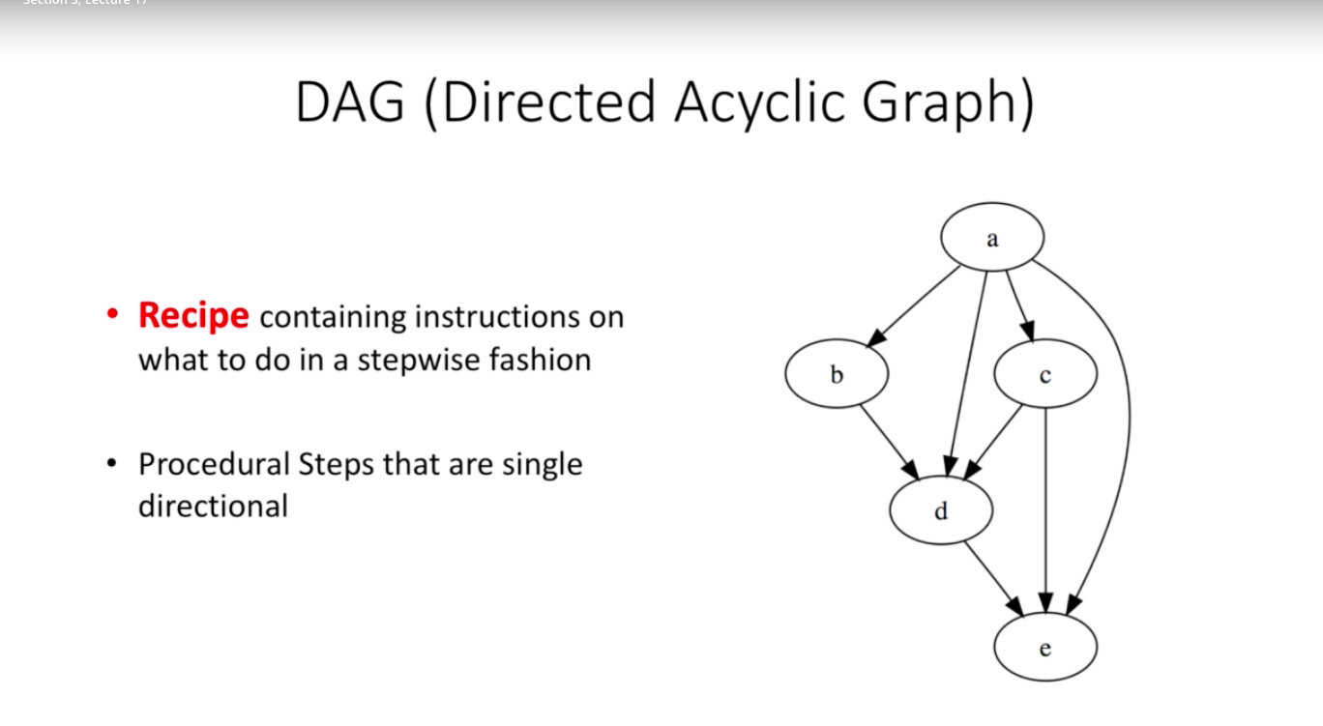

This is also called lazy execution .Spark is being lazy in how it executes its program.This is a good thing .The reason being :-

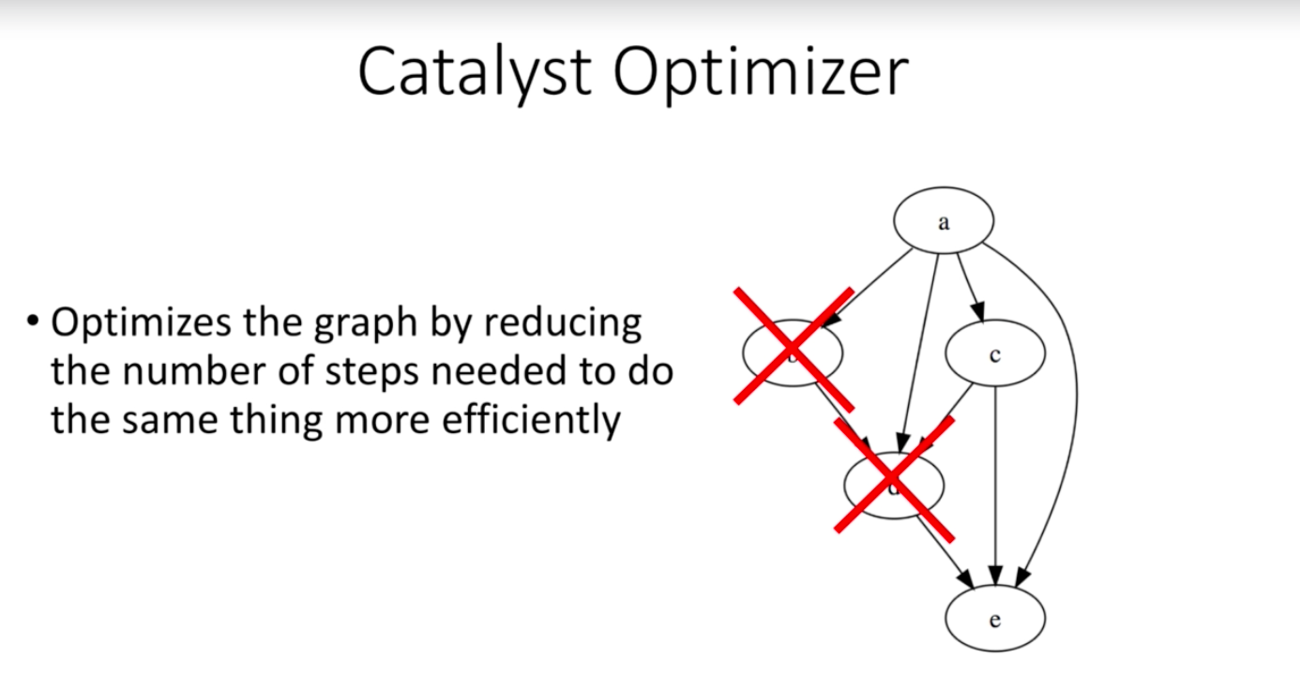

So it creates all instructions in a recipe sheet called DAG and only after seeing action command it makes sure which are the transformations which actually needs to be performed.

By Default , spark s configured to work with 128 MB per partition.

The link is localhost:4040/jobs/

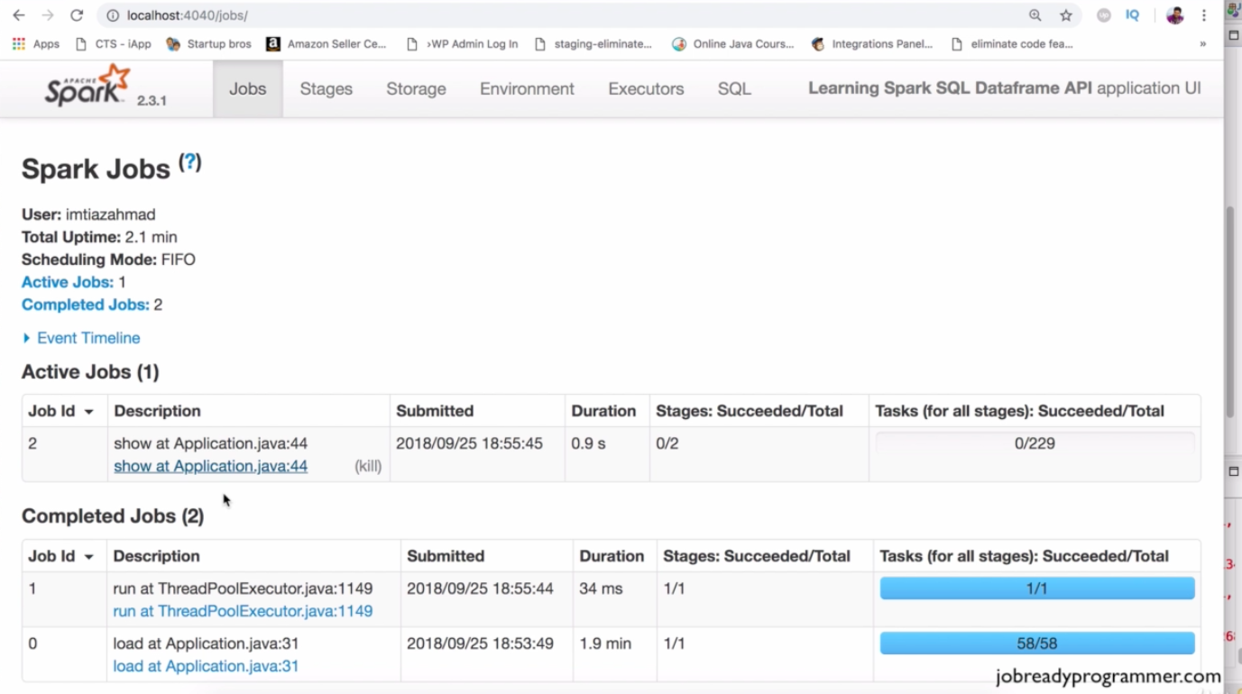

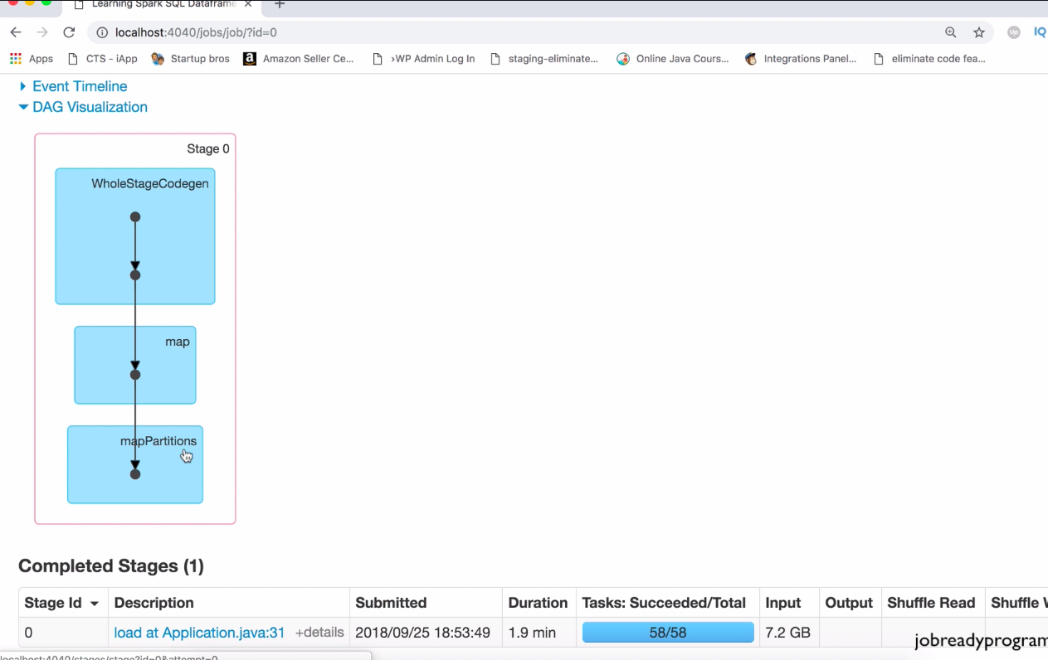

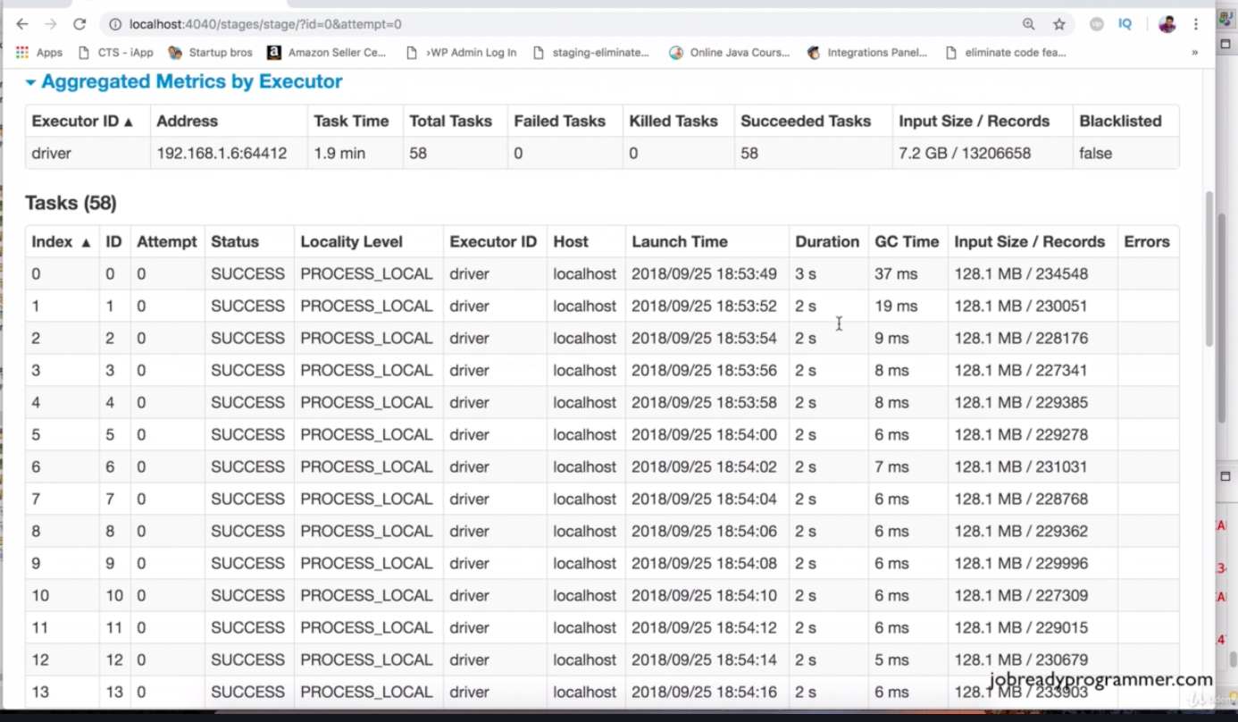

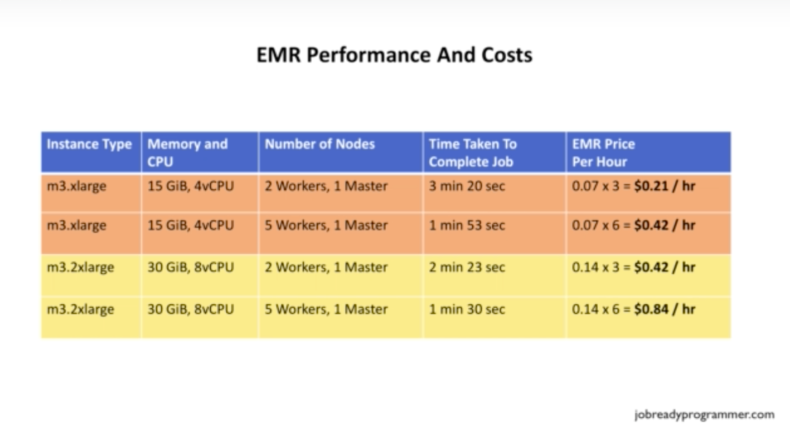

So To decide the the size of your cluster from above benchmark we can say that .

1)Take the normal size of your input data .

2)Dividing it by 128 gives number of partitions and then every node should be running max 5 partitions.

**So number of node in the cluster should be = file size/128/5**

Spark is capable of doing incremental processing of data and this is called spark streaming.Data frame apis can be used in the same way for spark streaming jobs as it was used for the batch jobs.With spark streaming , your cluster has the capability of ingesting and processing much smaller chunks of data on a continuous basis. Perhaps , just process 1 gb of data every few mins and the programme could add that to the running total of results that get refreshed on the dashboard every few minutes. So the company executives will have very up to date information every time they refresh their reporting dashboard. And the spark sql engine will take care of it running incrementally and continuously and updating the final results as streaming data continues to arrive all ensuring scalability and fault tolerance.

Structured streaming programming guide:-

<https://spark.apache.org/docs/latest/structured-streaming-programming-guide.html>

Have bookmarked this . Please note that you use this link as there is another link for older version of spark.no point studying that.

This should be your 1st resource when you start studying spark streaming :-

<https://spark.apache.org/docs/latest/structured-streaming-programming-guide.html>

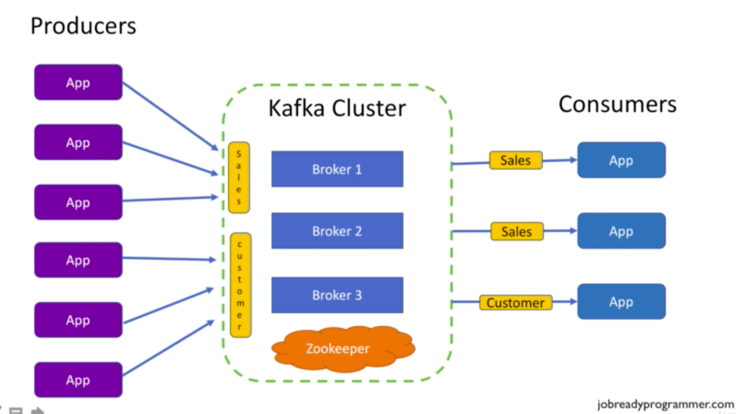

**Overview Of Logistic Regression**

The logistic regression algorithm even though has the word regression in the title

does not fall in the category of regression algorithms. It's actually known as a **classification** algorithm.

The word regression in it's title is just there due to historical reasons that are

not worth discussing. So, it's a classification algorithm, so what does classification mean?

Here are some examples of classification problems:

The prediction of whether an email is spam or not spam based on the contents of that email.

Or to predict whether a student would be accepted at a university or rejected based on their entrance exam score

Or whether someone is obese or not obese based on their weight.

Or whether someone is approved for a loan or not approved for the loan based on their income

Or to predict whether someone has a disease or does not have the disease based on their symptoms.

In the case of logistic regression, the dependent variable Y takes on a binary value. meaning either 1 or 0. Which

represents either a true or false for a given scenario. And the outcome of 1 or 0 is determined based on a probability

percentage. So for example, if the probability of a student getting accepted at a university program

is 0.7, that would qualify as a 1 because 0.7 is closer to 1 than it is to 0.

1 means, that the student would be accepted at the university. But if the probability

was 30 percent, 0.3, then the predicted outcome would be 0. Meaning the student doesn't get accepted.

So that is how classification works in binary logistic regression. You can classify things into 2 groups

either yes or no for a given scenario.

This is a graph of a binary logistic regression problem.

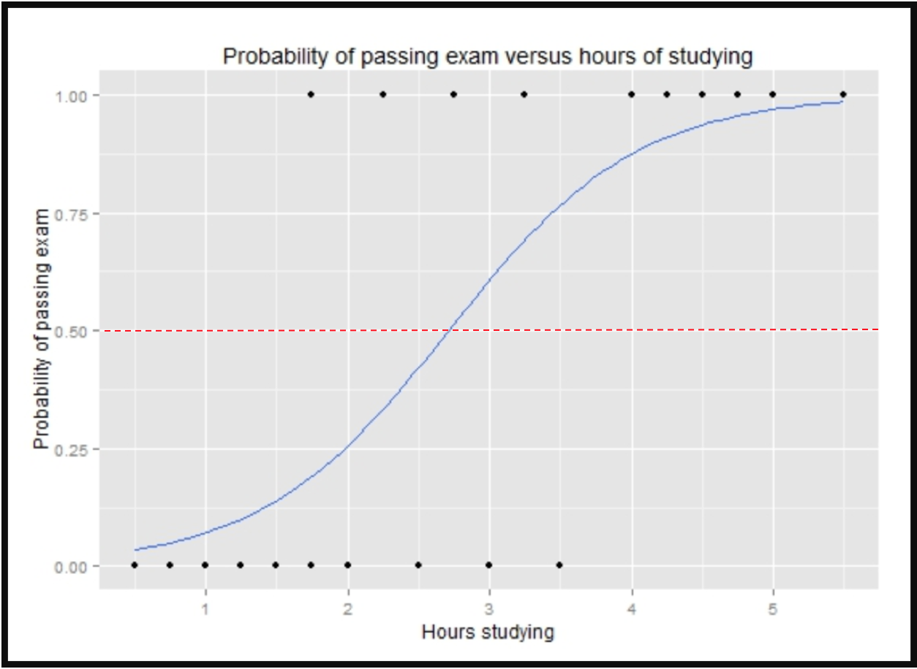

Notice the blue curve is not a straight line (unlike linear regression). The reason is that the equation used to graph a logistic regression is different than the equation used for graphing a linear regression. Since this is not exactly a machine learning course, I want to save you from all the math as to how this graph is created but notice that the dependent variable Y is bound to be either a 1 or 0. This allows us to predict binary outcomes such as pass/fail, win/lose, alive/dead or healthy/sick.

The above graph is an example of the logistic function to predict whether the student would pass or fail a test based on the amount of hours spent studying for the exam. The hours spent studying is a the x axis and the y axis has just 2 values either 1 or 0. (Pass/Fail)

Notice the cut off point is about 2 hrs and 45 minutes. If a student studies longer than that, their probability of passing the test is greater than 50 % so that student could be classified as a passing student. Any student that studies less than that cut-off point is  a failing student.

So that's the high level overview of logistic regression. If you'd like to learn the math behind this at a deeper level, refer to the book titled An introduction to statistical learning. As I mentioned earlier, it's an excellent book that anyone who is serious about getting into the artificial intelligence space must read. In the next lecture, we'll learn how you can use Spark MLLib to implement logistic regression. Stay tuned and I'll see you in the next lecture.